CASE STUDY NO82 Multi-Criteria Internship Candidate Ranking
1.Problem Statement
Evaluate internship candidates using marks, assessment scores, attendance, and eligibility requirements, then rank eligible candidates with deterministic tie-breaking.
2. Objectives
Combine multiple eligibility conditions.
Store candidate details in tuples and lists.
Sort eligible candidates using a transparent ranking rule.
3. Assumptions
Minimum academic marks: 70/100.
Minimum assessment score: 60/100.
Minimum attendance: 75%.
Ranking is by assessment score descending, then academic marks descending, then attendance descending, then candidate name alphabetically.
4. Algorithm
1. Read candidate count and each candidate's name, academic marks, assessment score, and attendance.
2. Validate that all numeric values are within 0–100.
3. Mark a candidate eligible only if all three minimum requirements are met.
4. Store eligible candidates as tuples.
5. Sort by assessment score, academic marks, attendance, then name.
6. Print the ranked list and candidates who did not qualify.
5. Flowchart
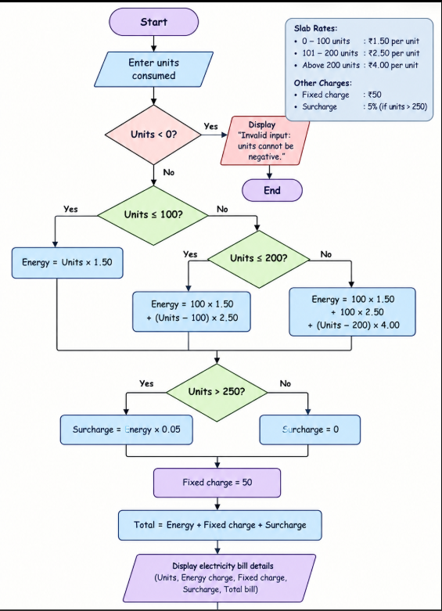

6. Pseudocode
START
INPUT n
FOR each candidate: INPUT name, marks, assessment, attendance
VALIDATE all scores in 0..100
IF marks >= 70 AND assessment >= 60 AND attendance >= 75: add eligible tuple
ELSE record unmet criteria
SORT eligible by assessment desc, marks desc, attendance desc, name asc
PRINT ranking and rejected reasons
END
8. Test Cases
Test | Input / Scenario | Expected result
1 | A: marks 80, assessment 90, attendance 90; B: 90, 90, 80 | A ranks before B because assessment ties and academic marks break the tie
2 | C: marks 65, assessment 90, attendance 90 | C rejected: academic marks below 70
3 | D: 75, 80, 75; E: 75, 80, 75 | Alphabetical name order breaks complete score tie

9.Screenshot
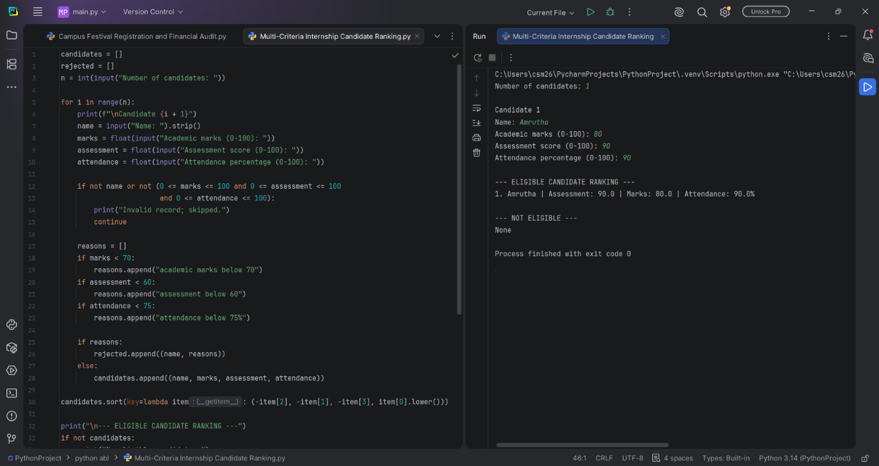

10. Conclusion
The program applies eligibility thresholds and ranks qualifying candidates with explicit, repeatable tie-breaking rules

